8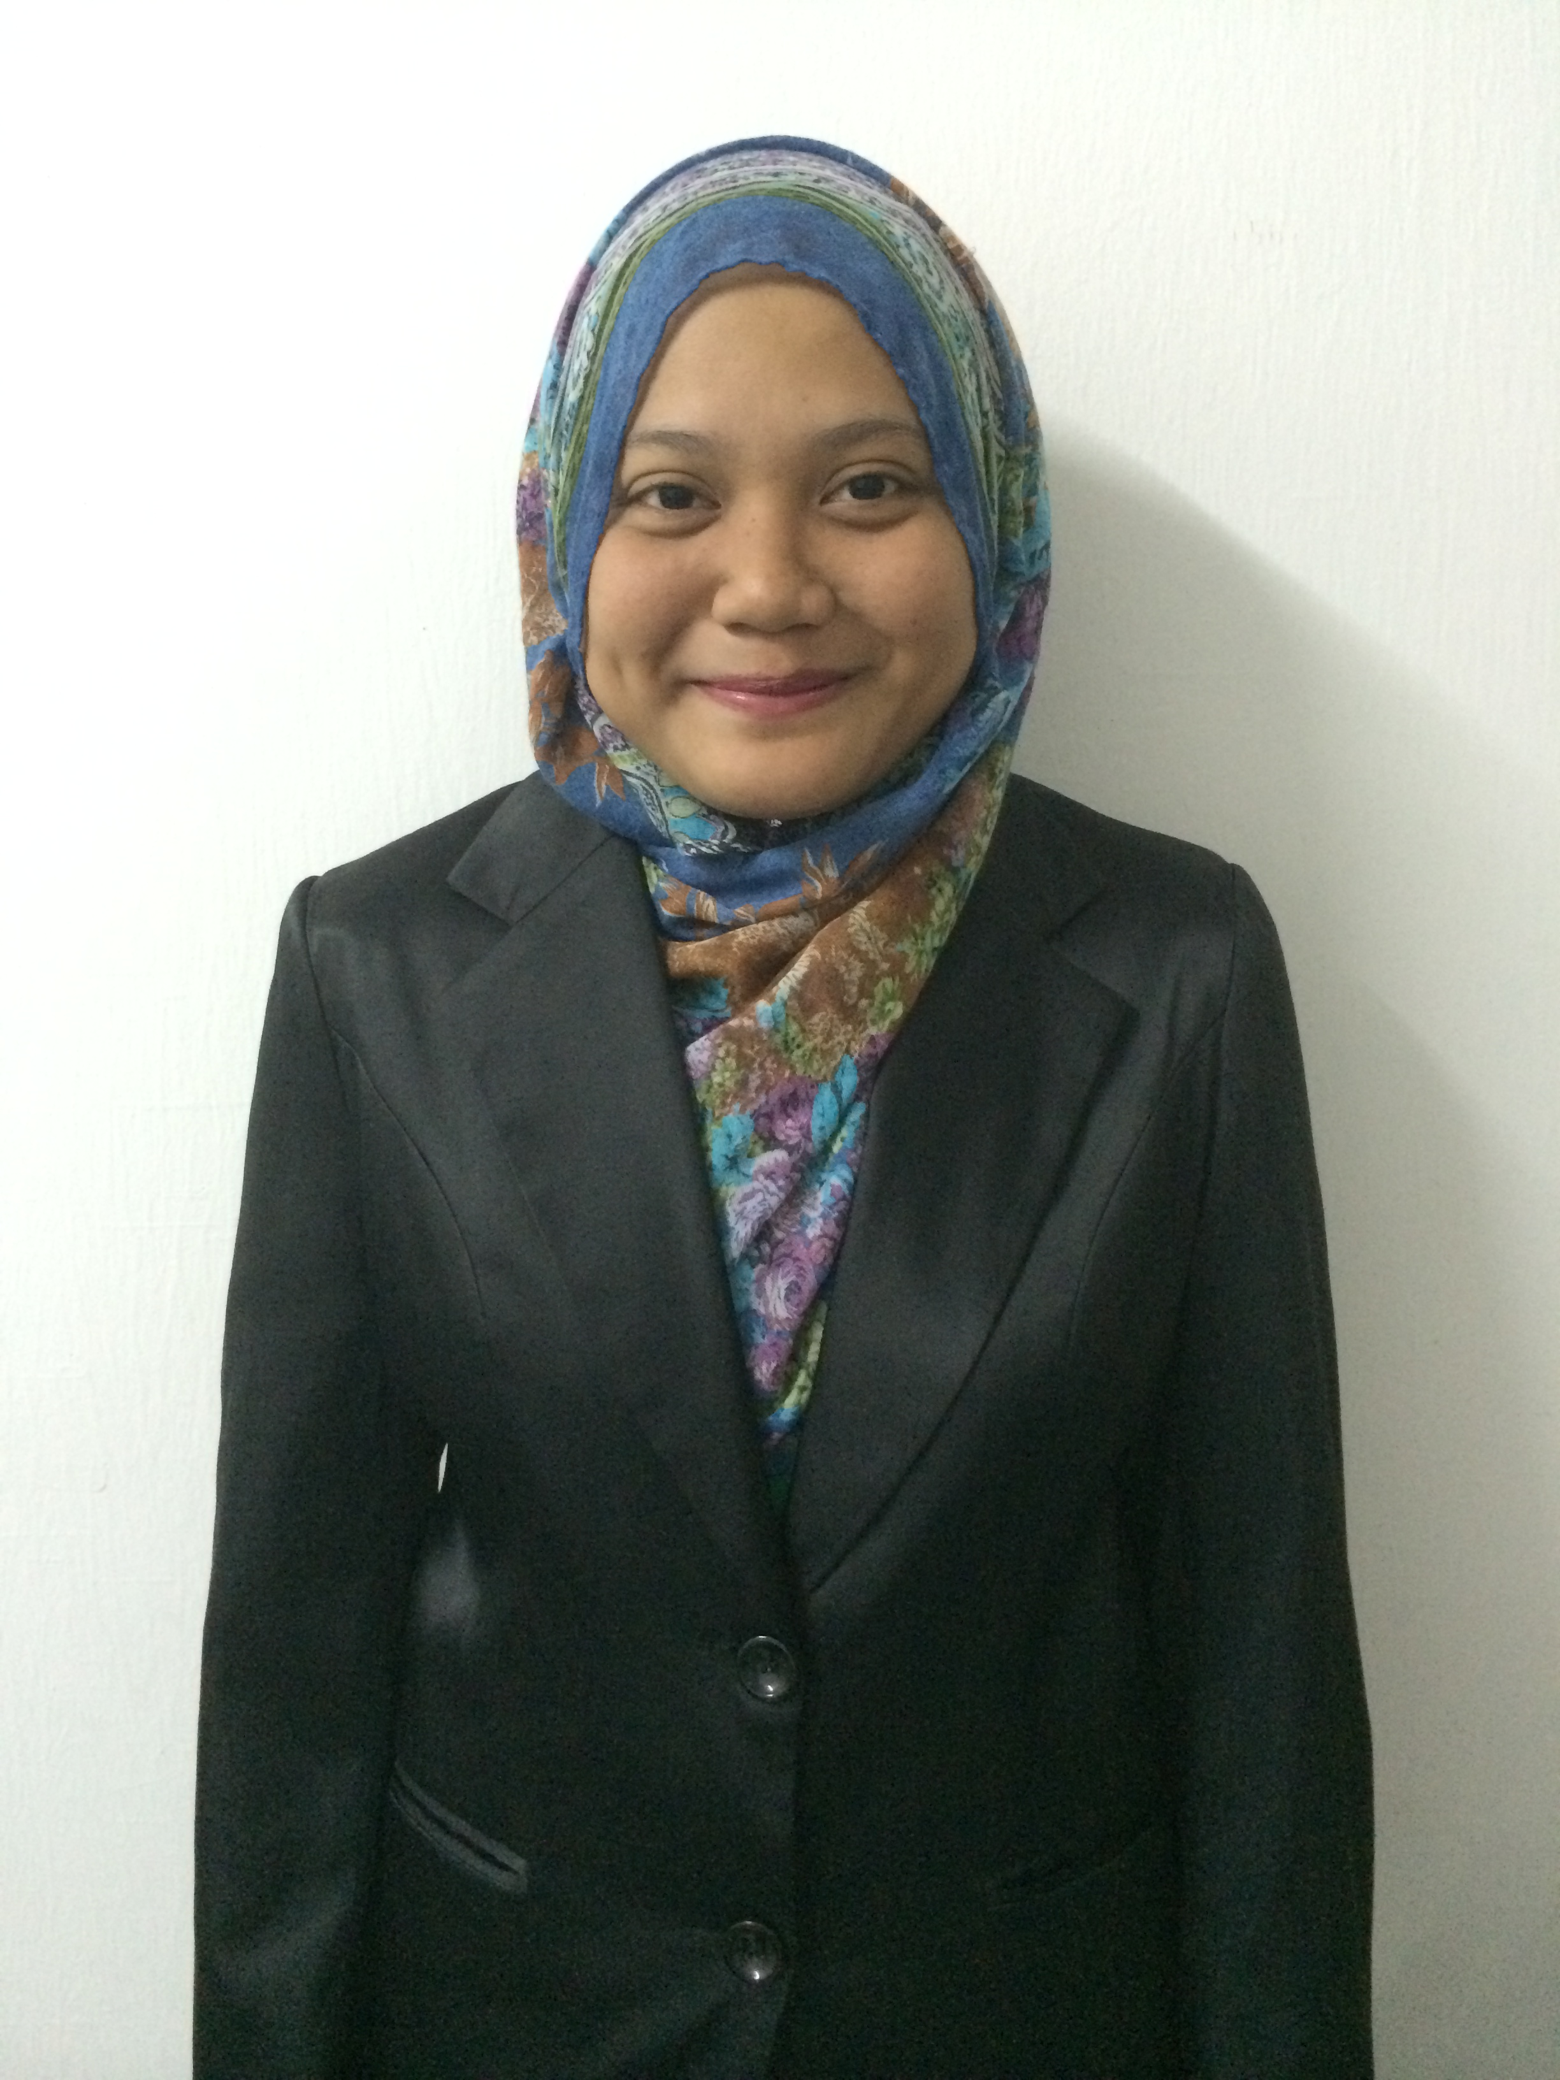

NUR FAUZEEHANANI BINTI YAHYA
No. 2, Jalan Kiambang 8
Taman Sri Pandan
81100 Johor Bahru
Johor Darul Takzim

Tel (Hp): 011-17619611
nurfauzeehananiyahya@yahoo.com

PERSONAL PARTICULAR

Name : Nur Fauzeehanani binti Yahya
NRIC No. : 921028-01-6482
Date of Birth : 28 October 1992
Age : 25
Gender : Female
Nationality : Malaysian
Race : Malay
Religion : Islam
Marital Status : Single

CAREER OBJECTIVES

To have a dynamic, challenging and creative working environment in which to learn and grow acquired skills.

EDUCATIONAL BACKGROUND

2013 – 2015 : Bachelor in Health Administration (Hons.) (BM235)
Mara University of Technology (UiTM); (CGPA: 3.45)

2010-2012 : Diploma in Office Management and Technology (OM114)
Mara University of Technology (UiTM); (CGPA : 3.79)

2009 : Sijil Pelajaran Malaysia (SPM)
Sekolah Menengah Teknik Pontian, Johor
3A, 7C

SKILLS AND ABILITIES

Word Processing | : | Keyboarding with speed and accuracy
 | : | Knowledge and skill in use of software programs
 | : | Skill in formatting and proofreading documents
Data Processing | : | Ability to interpret data including coding the diseases
 | : | Ability to maintain an organized workstation
 | : | Proficiency with spread sheet, database, and related software programme
Information Management & Transmission | : | Ability to find the information needed and to maintain or develop health information system
 | : | Ability to give attention to details
 | : | Ability to work with others
General Managing & Communication | : | Establish priorities  Use a personal computer and manage files
Typing Skills | : | 55 wpm
Language | : | Malay, English
WORK EXPERIENCE

1. Company Name : Jadiharta Urusan Sdn Bhd
Position : Admin Executive (2016)

Work Description:
- Performs administrative and office support activities for multiple supervisors.
- Act as the point of contact between the executives and internal/external clients
- Undertake the tasks of receiving calls, take messages and routing correspondence
- Handle requests and queries appropriately
- Monitor office supplies and research advantageous deals or suppliers
- Develop and carry out an efficient documentation and filing system

2. Company Name : Nilai Medical centre
Position : Industrial Trainee (Feb 2015 – June 2015)

Work Description:
- Front Office Department and Medical Record Department
- Handling all the patient’s insurance coverage, filing all the case note and also entertain patient at the registration counter.

3. Company Name : Sincerelybus Boutique
Position : Boutique Asistant (Part-time)

Work Description:
- Entertaining and welcoming customer and sorting all the items in the shop.

4. Company Name : Charisma Marine Sdn Bhd
Position : Clerk (2013)

Work Description:
- Searching tender for the company and helping in general administration task.

5. Company Name : Aiman & Safa Kid’s Clothing
Position : Promoter – Part time (2012)

Work Description:
- Entertaining customer and sorting all the items.

MISCELLANEOUS

Profiles : I really look forward for a job. I don't mind to work from below and I am hardworking person and
love to learn something new.

Willing to travel : Yes
Willing to relocate : Will Consider
Possess License : Yes (D)
Possess Own Transport : Yes

Expected Monthly Salary : RM1,800.00 (Can negotiate)
Availability : As soon as possible

REFERENCE

Aziz bin Jamal
Supervisor,
Faculty of Business Management
Universiti Teknologi MARA
Kampus Puncak Alam, Bandar Puncak Alam
42300 Selangor
016-8027800

Mohamad Shahril bin Mohamad Besir
Lecturer,
Faculty of Business Management
Universiti Teknologi MARA
Kampus Puncak Alam, Bandar Puncak Alam
42300 Selangor.
012-2542923

Liatul Izian binti Ali Hussin
Personal Advisor of Academic
Faculty of Business Management
University Teknologi MARA
Kampus Puncak Alam, Bandar Puncak Alam
42300 Selangor
012-2539265

